**DAILY ONLINE ACTIVITIES SUMMARY**

|  |  |  |  |  |  |  |  |  |
| --- | --- | --- | --- | --- | --- | --- | --- | --- |
| **Date:** | **14/07/2020** | | | | | **Name:** | **POOJA D S** | |
| **Sem & Sec** | **IV Sem & B section** | | | | | **USN:** | **4AL18CS056** | |
| **Online Test Summary** | | | | | | | | |
| **Subject** | | **-** | | | | | | |
| **Max. Marks** | | **30** | | **Score** | | | **-** | |
| **Certification Course Summary** | | | | | | | | |
| **Course** | **Predictive Modeling and Analytics** | | | | | | | |
| **Certificate Provider** | | | **Great learning academy** | | **Duration** | | | **5.5hours** |
| **Coding Challenges** | | | | | | | | |
| **Problem Statement1:** Write a java program to check for balanced parenthesis. | | | | | | | | |
| **Status: Executed** | | | | | | | | |
| **Uploaded the report in Github** | | | | | **YES** | | | |
| **If yes Repository name** | | | | | <https://github.com/dspooja/Java-coding> | | | |
| **Uploaded the report in slack** | | | | | **YES** | | | |

Online Test Summary: No internals conducted today.

Online Certification Course Summary: Today I have learnt about Logistic Regression- Hands- on, Discrimination Analysis, etc.

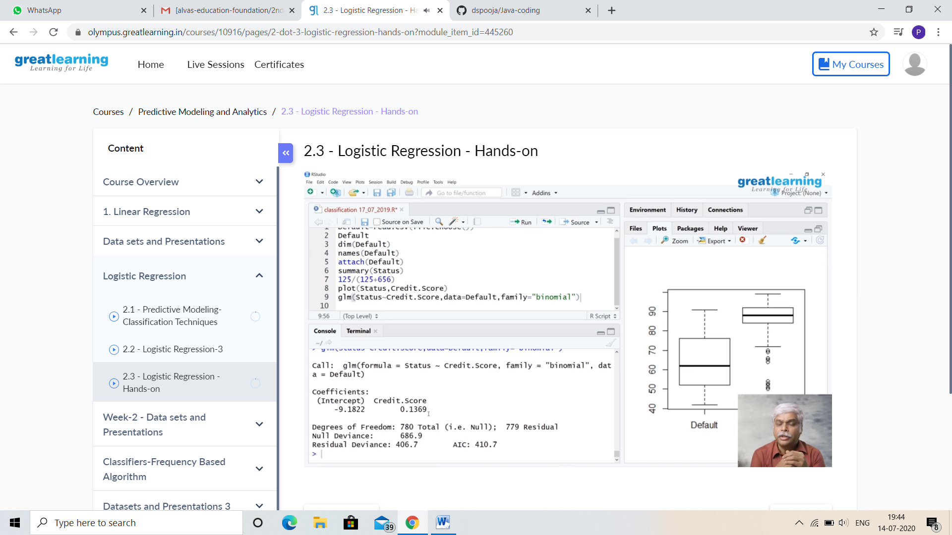

This is the Snapshot of the today’s certification course.

**Online Coding Summary: Today I had received one program from prof. Shilpa CSE Dept. The program is mentioned above in the coding challenges (pg.01). I have also uploaded it to my Github repository.**

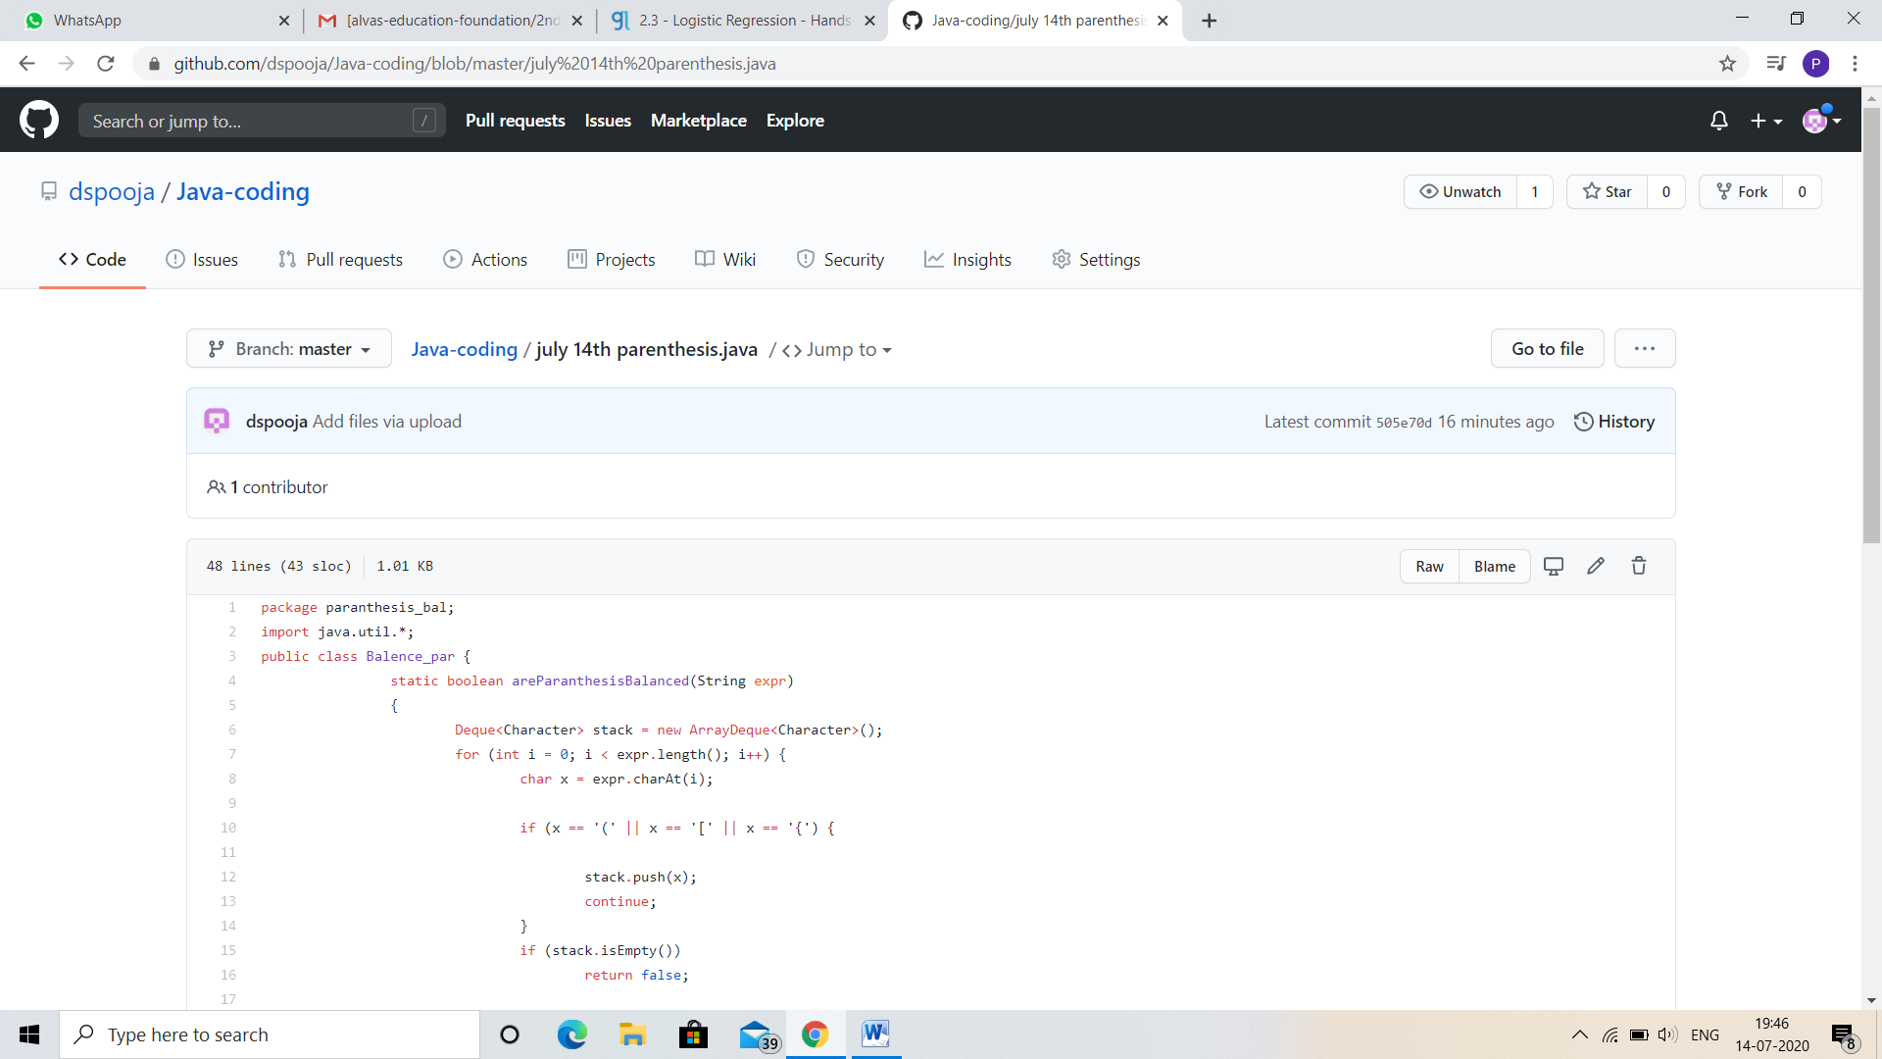

**This is the Snapshot of my Github repository** were I have uploaded the code. File name is parenthesis.java